<td><Button variant="primary" onClick={()=> onProductClick(product)}>View</Button> </td>

export default function Productstable({ products, onProductClick })

Home function:

const [selectedProduct, setSelectedProduct] = useState(null);

    const [show, setShow] = useState(false);

    const handleClose = () => setShow(false);

    const handleSelectedProduct = (product) => { setSelectedProduct(product); setShow(true)}

<Productstable products={products} onProductClick={handleSelectedProduct}/>

        <ProductModal selectedProduct={selectedProduct} show={show} handleClose={handleClose}/>

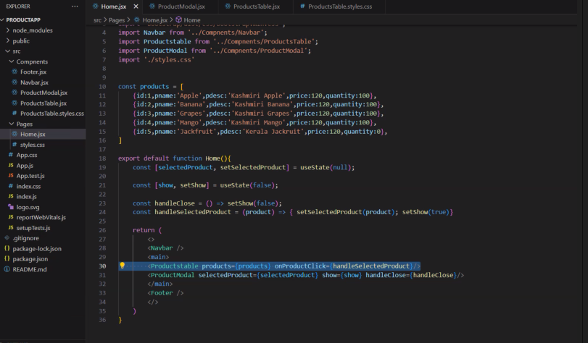

export default function({selectedProduct, show, handleClose}){

    if(show){

    return (

        <Modal show={show} onHide={handleClose}>

        <Modal.Header closeButton>

          <Modal.Title>{selectedProduct.pname}</Modal.Title>

        </Modal.Header>

        <Modal.Body>

            <Container>

                <Row>

                    <Col><strong>Product Description</strong></Col>

                    <Col>

                    {selectedProduct.pdesc}

                    </Col>

                </Row>

                <Row>

                    <Col><strong>

                    Price

                        </strong>

                        </Col>

                    <Col>

                    {selectedProduct.price}

                    </Col>

                </Row>

                <Row>

                    <Col><strong>Quantity</strong></Col>

                    <Col>

                    {selectedProduct.quantity}

                    </Col>

                </Row>

            </Container>

        </Modal.Body>

        <Modal.Footer>

          <Button variant="secondary" onClick={handleClose}>

            Close

          </Button>

        </Modal.Footer>

      </Modal>

    )}

}

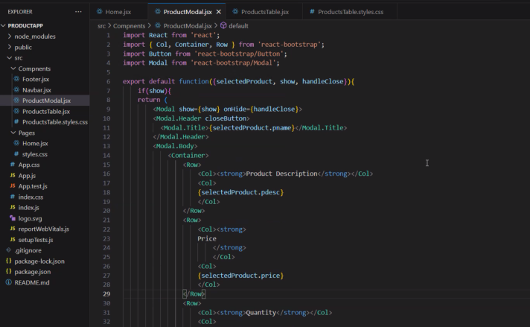

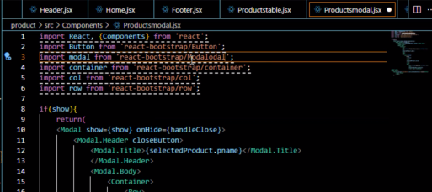

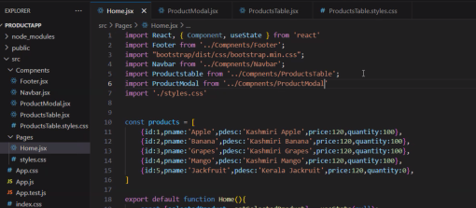

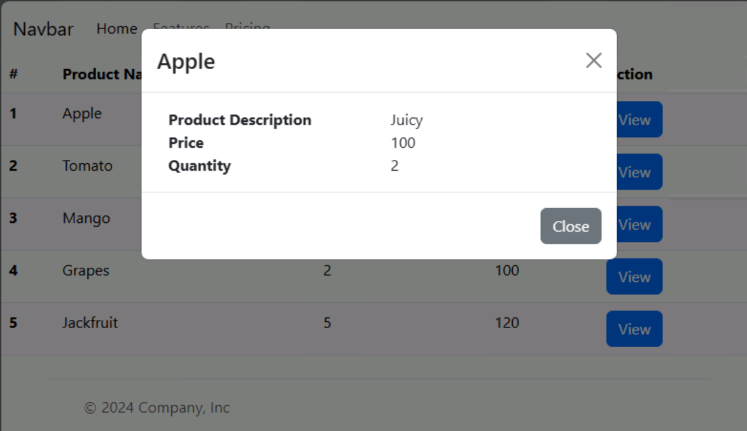

<https://react-bootstrap.github.io/docs/components/>

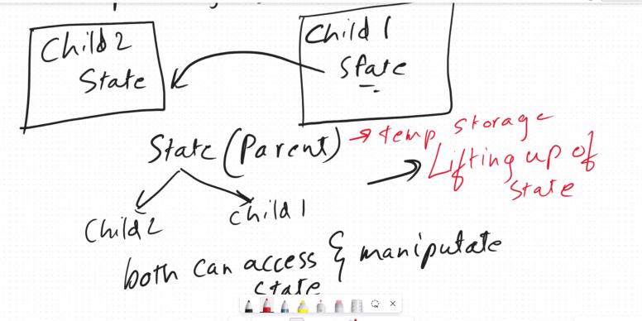

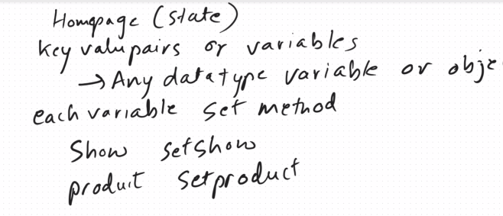

Global State Management (REDUX)

Routing in React

React Router DOM (Package)

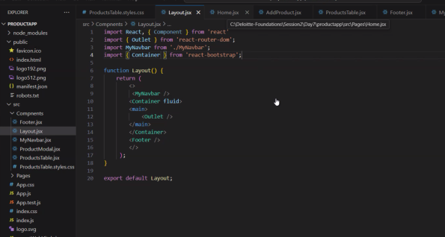

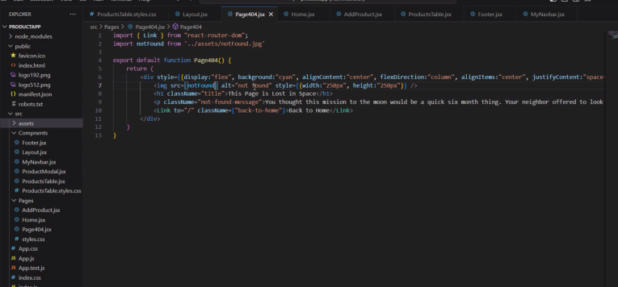

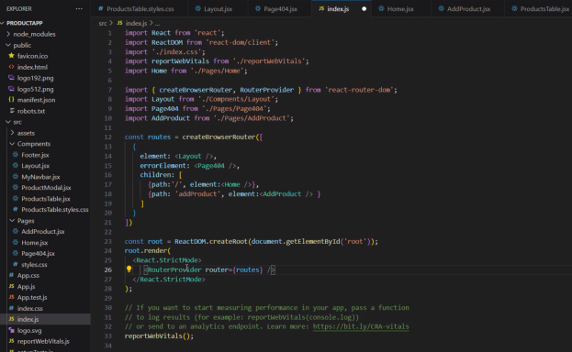

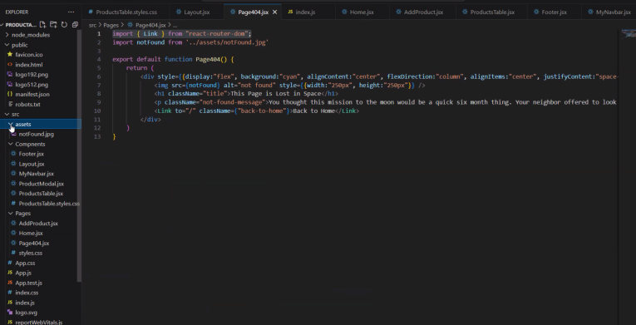

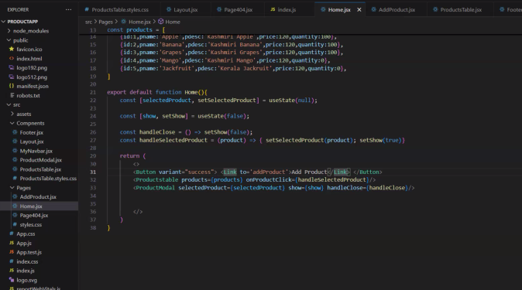

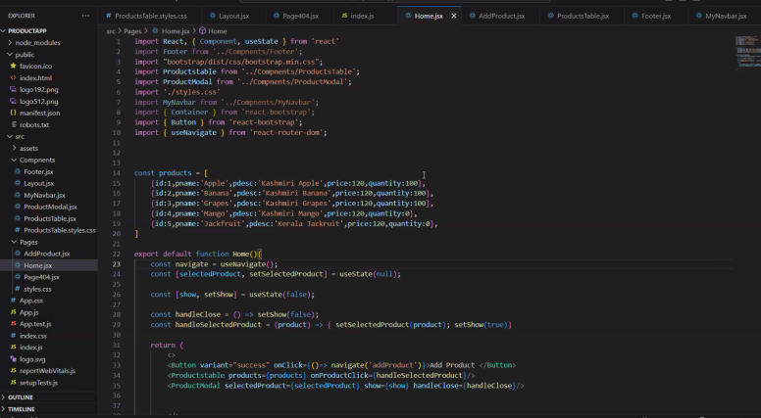

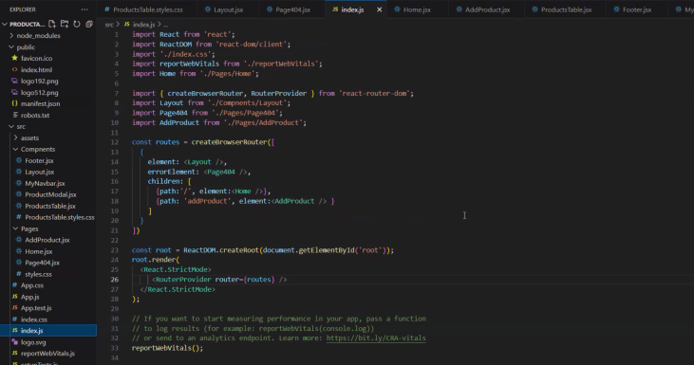

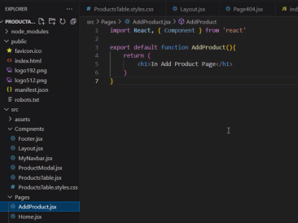

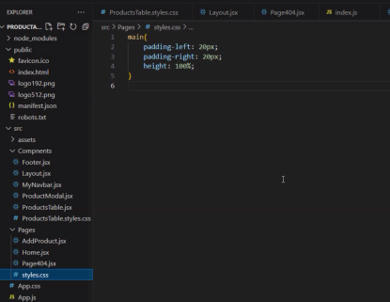

<https://codeshare.io/VNdzX9>

<https://reactrouter.com/en/main/upgrading/v5>

Totally new Create new folder (randomUserApp)

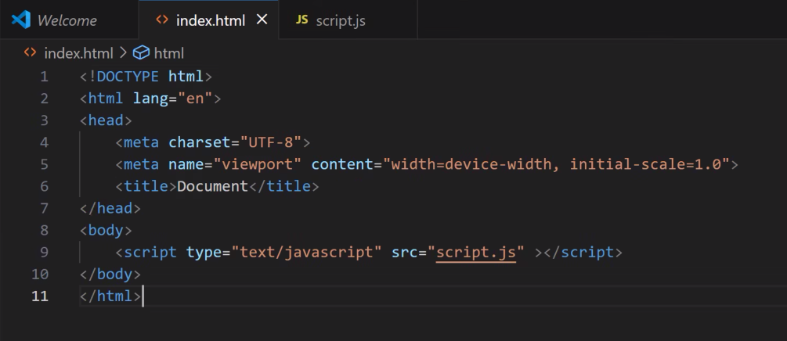

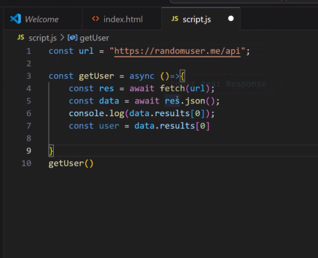

My code:

Index.html

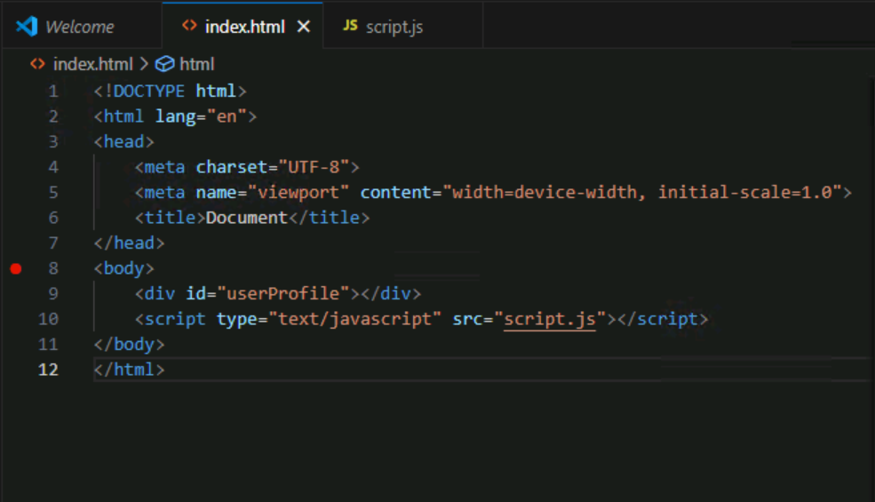

Script.js

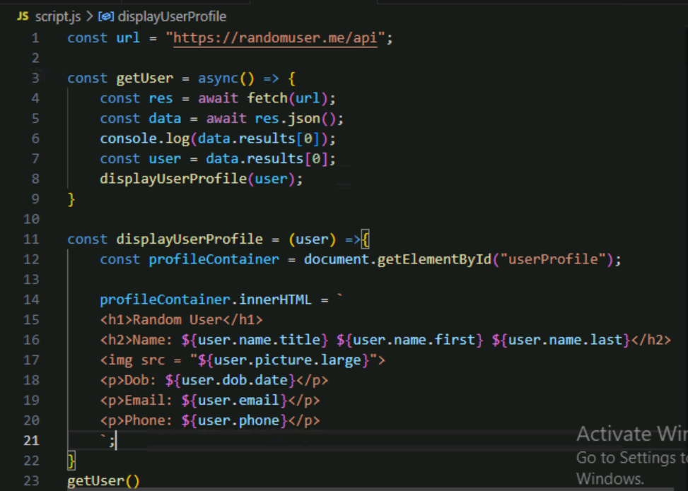

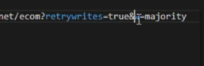

After connecting npm install

Node app.js

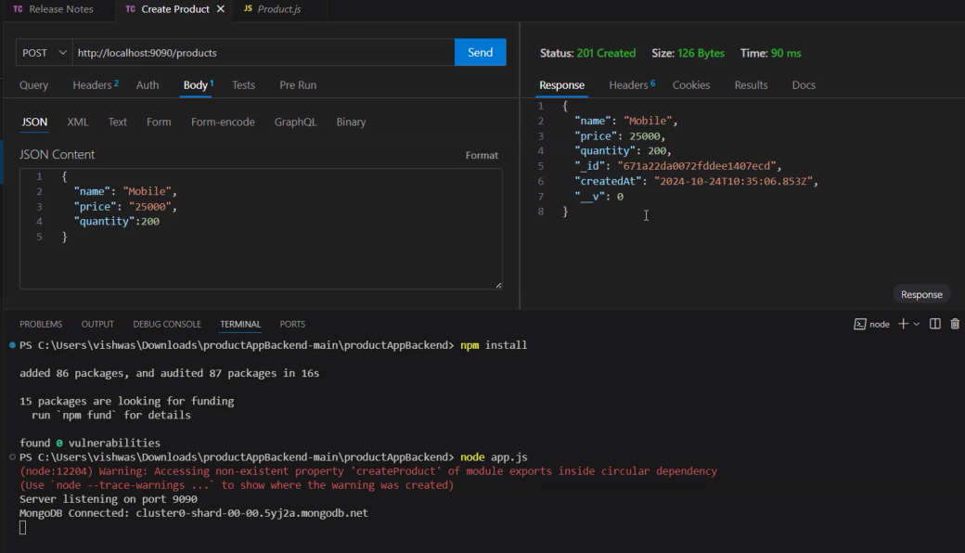

Api to get data form the server

Fetch api

Axios api

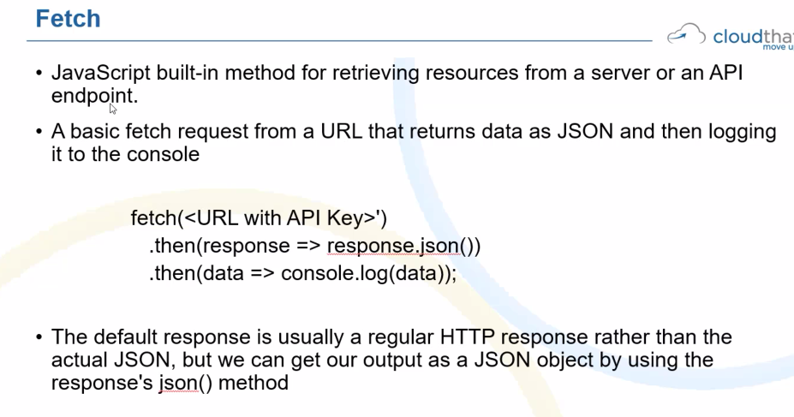

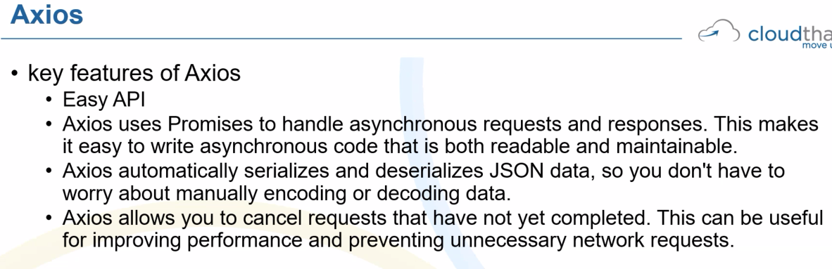

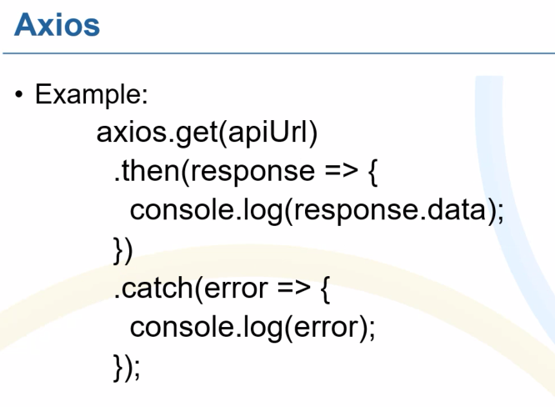

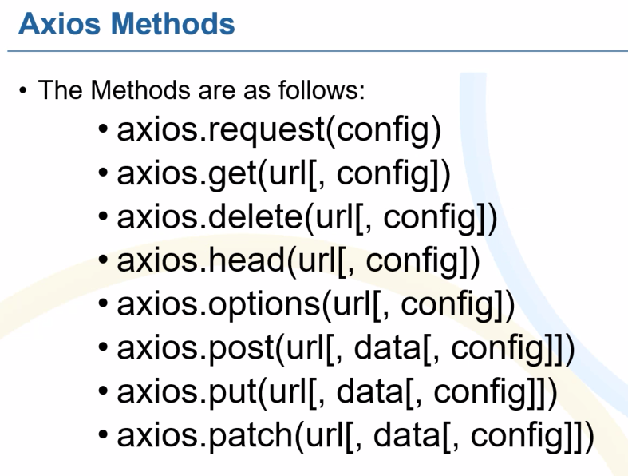

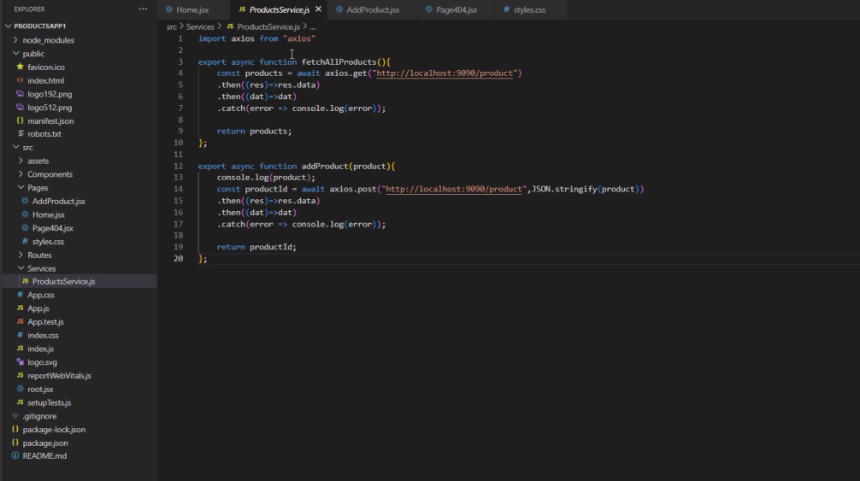

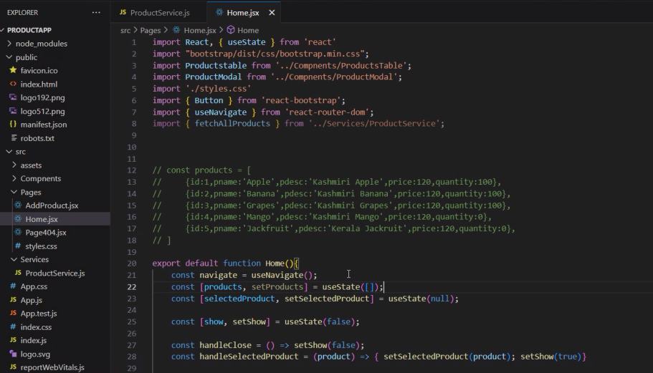

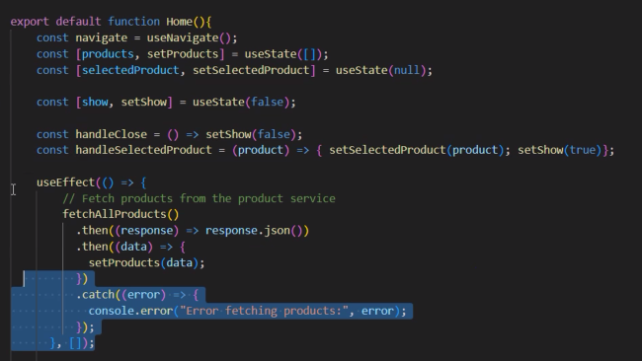

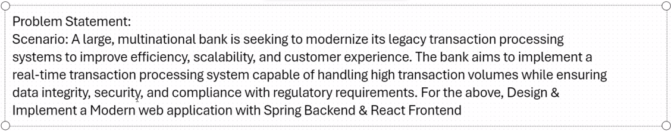

    useEffect(() => {

        // Fetch products from the product service

        fetchAllProducts()

          .then((response) => response.json())

          .then((data) => {

            setProducts(data);

          })

          .catch((error) => {

            console.error("Error fetching products:", error);

          });

      }, []);

    const [products, setProducts] = useState([]);

AddProduct code:

import { useState } from "react";  
import { addProduct } from "../services/ProductsService";

const AddProduct = () => {  
  const [name, setName] = useState("");  
  const [price, setPrice] = useState(0.00);  
  const [quantity, setQuantity] = useState(0);

  const handleChange = (event) => {  
    const { name, value } = event.target;  
    switch (name) {  
      case "name":  
        setName(value);  
        break;  
      case "price":  
        setPrice(parseFloat(value)); // Ensure price is a number  
        break;  
      case "quantity":  
        setQuantity(parseInt(value)); // Ensure quantity is an integer  
        break;  
      default:  
        break;  
    }  
  };

  const handleSubmit = async (event) => {  
    event.preventDefault();  
    console.log("Form submitted");

    const formData = { name, price, quantity };  
    console.log(formData);  
    const { data } = await addProduct(formData);  
    console.log(data);  
    // history.pushState(formData, "/home");  
  };

  return (  
<>  
<h1 style={{ marginLeft: "10px" }}>Add Product</h1>  
<div className="container" style={{ padding: "10px", display: "flex", flexDirection: "column", justifyContent: "space-evenly" }}>  
<form onSubmit={handleSubmit}>  
<label htmlFor="productName" className="form-label">Product Name</label>  
<input type="text" name="name" id="productName" className="form-control" onChange={handleChange} value={name} />

          <label htmlFor="productPrice" className="form-label">Product Price</label>  
<input type="number" name="price" id="productPrice" className="form-control" min="0" step="0.5" pattern="^\d+(?:\.\d{1,2})?$" onChange={handleChange} value={price} />

          <label htmlFor="productQuantity" className="form-label">Product Quantity</label>  
<input type="number" name="quantity" id="productQuantity" className="form-control" min="0" step="1" pattern="^\d\*" onChange={handleChange} value={quantity} />

          <input type="submit" className="btn btn-success" style={{ marginTop: "10px" }} value="Submit" />  
</form>  
</div>  
</>  
  );  
};

export default AddProduct;

